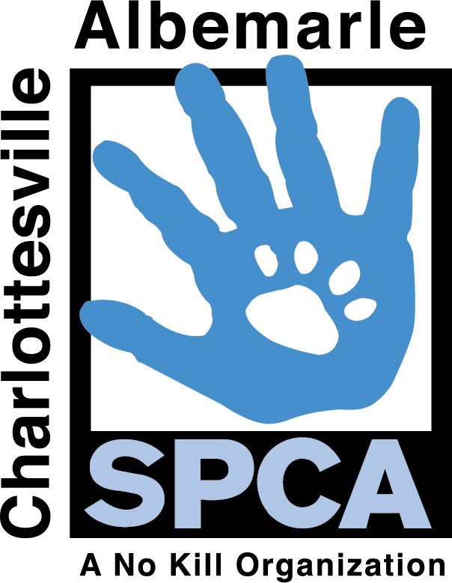
February 6, 2017
Madeleine Rhondeau
Marketing & Communications Manager
(434) 973-5959
mrhondeau@caspca.org
Charlottesville-Albemarle SPCA

Charlottesville, VA
Charlottesville Albemarle SPCA
FOR IMMEDIATE RELEASE

It’s A Slam Dunk Adoption Special – 50% Off Adoption Fees at the Charlottesville-Albemarle SPCA

Charlottesville, VA— It’s Team Dog vs. Team Cat at the Charlottesville-Albemarle SPCA in preparation for this year’s 2017 March Madness tournament. Your family’s MVP is waiting at our shelter to brighten your life and add a little more love to you world. From March 20th to March 31st, all adult cats and dogs have a 50% off adoption fee. Senior dogs and FIV cats always have a waived adoption fee!

Come out and show your “Team” some love by adopting a Game Day pal from the Charlottesville-Albemarle SPCA.

For full details about the “It’s A Slam Dunk” pet adoption special please visit caspca.org

About the Charlottesville-Albemarle SPCA: The Charlottesville-Albemarle SPCA is proud to have maintained the City of Charlottesville and Albemarle County as a No Kill community, providing life-saving care to thousands of animals in the region. The mission of the CASPCA is to advance the compassionate treatment of animals by providing sheltering, medical care and behavioral services for dogs and cats; promoting permanent, caring homes; and furthering education and outreach to place healthy animals in caring homes.

For more information about the CASPCA, call 434-973-5959, or visit our website at caspca.org. The CASPCA’s main adoption center is located at 3355 Berkmar Drive in Charlottesville and is open seven days a week from 12PM– 6PM.

To become a fan of the CASPCA on Facebook go to: https://www.facebook.com/caspca/
Follow the CASPCA on Twitter: https://twitter.com/CASPCA

