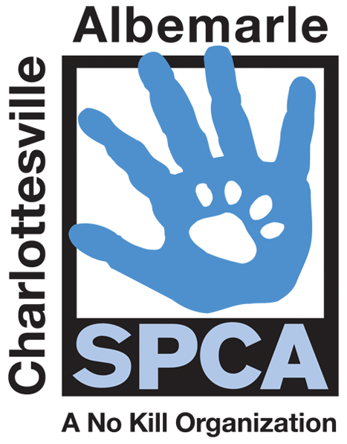

FOR IMMEDIATE RELEASE Contact: Lisa Lane
Charlottesville-Albemarle SPCA (434) 964-3305 | (805) 451-0154
10/22/2014 llane@caspca.org

SPCA Hosts Its Own World Series

Charlottesville, Virginia: While sports fans are following the World Series, the Charlottesville-Albemarle SPCA is giving animal lovers a reason to tune in and root for their favorite breed by hosting the World Series of Wags. It’s Pitties Vs. Hounds in the World Series of Wags and the winner will be the breed team to score the most adoptions through the end of October. So far, the Pitties have a two to zero lead over the Hounds, but the first inning has just begun. Either type of canine companion can slide in to a home for just $9. This amazing $9 adoption deal comes with services normally costing hundreds of dollars, including spay/neuter, age-appropriate vaccinations, de-worming, a custom ID tag, a Save-This-Life Microchip with lifetime registration, plus a free medical exam from participating vets, a free animal behavior CD and a lifetime of priceless companionship and fun.

The Pittie Team includes all Pit Bulls, American Staffordshire Terriers and American Bulldog Mixes. The Hound Team is made up of all Hound mixes including Foxhounds, Coonhounds and Treeing Walker Coonhounds. There are dozens of dogs to choose from with varying temperaments. We’ve got couch potatoes ready to curl up with you, the best running buddies you can find, or your dog’s new BBF. Don’t’ strike out, this home run of a deal ends on October 31st.

The mission of the Charlottesville-Albemarle SPCA is to provide a safe and nurturing environment for the lost, abandoned, and homeless animals of the City of Charlottesville and the County of Albemarle and to increase the number of these animals being placed in appropriate, loving, and permanent homes through adoptions, foster care, and outreach, and to set a standard of excellence and leadership in shelter animal care, humane education, and progressive animal welfare programs.

For more information about the Charlottesville-Albemarle SPCA call 434-973-5959 or visit our website at www.caspca.org. The SPCA’s main adoption center is located at 3355 Berkmar Drive in Charlottesville and is open seven days a week from 12 PM– 6 PM. #######################

