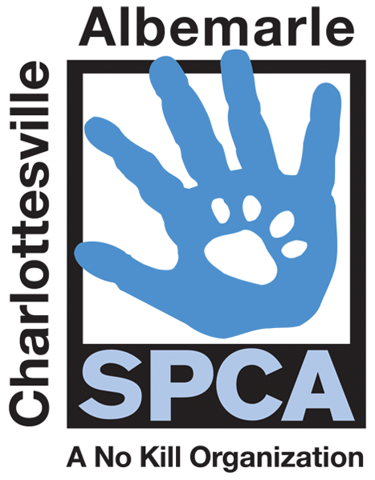

FOR IMMEDIATE RELEASE Contact: Lisa Lane
Charlottesville-Albemarle SPCA (434) 964-3305 | (805) 451-0154
06/13/2014 llane@caspca.org

Charlottesville-Albemarle SPCA Rabies & Microchip Clinic
to be held on Sunday, June 22nd

Charlottesville, Virginia: The Charlottesville-Albemarle SPCA is offering the public a way to protect their pets in three important ways at a very low cost. On Sunday, June 22nd from 11AM to 3PM, the Charlottesville-Albemarle SPCA is holding a low-cost Rabies Vaccine and Microchip Clinic. Pet owners can have their pet(s) vaccinated at the SPCA during this Clinic for just $10.00 per pet, have their pet microchipped for $25.00 or receive both services for just $30.00. Flea and tick preventative will also be available for purchase at a discounted rate. The Charlottesville-Albemarle SPCA is located at 3355 Berkmar Drive; the clinic will take place on the left side of the SPCA, in the building’s ground-floor education room.

Rabies is a deadly but preventable virus. In an effort to protect people and pets against the rabies virus, Virginia state law requires that all dogs and cats over the age of four months be vaccinated against rabies. The SPCA asks that Clinic attendees bring all dogs on a leash and all cats in a carrier. Pet owners will need to show proof of current rabies vaccine in order to receive a three-year vaccine. The clinic is first come, first served and limited to vaccine and microchips available. The microchips include a lifetime registration. This clinic is made possible with support from Boehringer Ingelheim.

“One in three pets will get lost in their lifetime and without identification 90% will not return home,” says Lisa Lane, Director of Marketing and Development at the Charlottesville-Albemarle SPCA. “We are happy to provide these three important services at an affordable price to help keep pets in our community healthy, safe and with their families.”

The mission of the Charlottesville-Albemarle SPCA is to provide a safe and nurturing environment for the lost, abandoned, and homeless animals of the City of Charlottesville and the County of Albemarle and to increase the number of these animals being placed in appropriate, loving, and permanent homes through adoptions, foster care, and outreach, and to set a standard of excellence and leadership in shelter animal care, humane education, and progressive animal welfare programs.

For more information about the Charlottesville-Albemarle SPCA call 434-973-5959 or visit our website at www.caspca.org. The SPCA’s main adoption center is located at 3355 Berkmar Drive in Charlottesville and is open seven days a week from 12 PM– 6 PM

#######################

