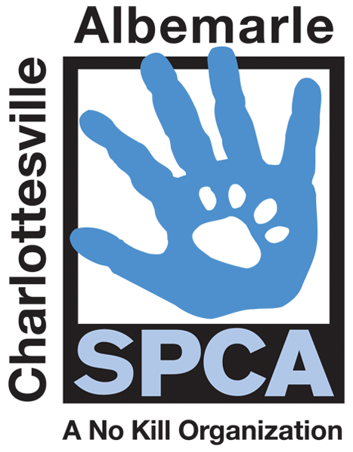

FOR IMMEDIATE RELEASE Contact: Lisa Lane
Charlottesville-Albemarle SPCA (434) 964-3305 | (805) 451-0154
04/09/2014 llane@caspca.org

Charlottesville-Albemarle SPCA to Offer Free Spay/Neuter for Cats
in Charlottesville/Albemarle through Mother’s Day

Charlottesville, Virginia: Spring is in the air and you know what that means. The Charlottesville-Albemarle SPCA is here to tell you that your cat doesn't want to be a momma. To help curb unwanted kitten births, now through Mother's Day the SPCA is offering the "I Don't Wanna Be a Momma" Spay/Neuter Special which will allow Charlottesville/Albemarle residents to have cats fixed for free through Mother's Day 2014. This special is for both male and female cats. The surgery includes a free rabies vaccine and pain medication. Appointments will fill up quick; residents are encouraged to apply now at caspca.org or by calling (434) 964-3333. Free trapping assistance is also available for feral and free roaming cats.

The SPCA reminds citizens that the warmer weather brings on breeding season for cats and that adolescent felines can give birth as young as five months. Typically, more than 1,100 homeless kittens arrive at the SPCA every year in need of care; most of these are the offspring of unfixed street and farm cats.

“Fixing free roaming cats, especially with the SPCA’s free cat fix price, is much less expensive than caring for a litter of unwanted kittens,” reminds Lisa Lane, Director of Marketing and Development at the Charlottesville-Albemarle SPCA. “We are thankful to have funding from PetSmart Charities to provide this important community service to prevent unwanted cat motherhood.”

The mission of the Charlottesville-Albemarle SPCA is to provide a safe and nurturing environment for the lost, abandoned, and homeless animals of the City of Charlottesville and the County of Albemarle and to increase the number of these animals being placed in appropriate, loving, and permanent homes through adoptions, foster care, and outreach, and to set a standard of excellence and leadership in shelter animal care, humane education, and progressive animal welfare programs.

For more information about the Charlottesville-Albemarle SPCA call 434-973-5959 or visit our website at www.caspca.org. The SPCA’s main adoption center is located at 3355 Berkmar Drive in Charlottesville and is open seven days a week from 12 PM– 6 PM.
#######################

