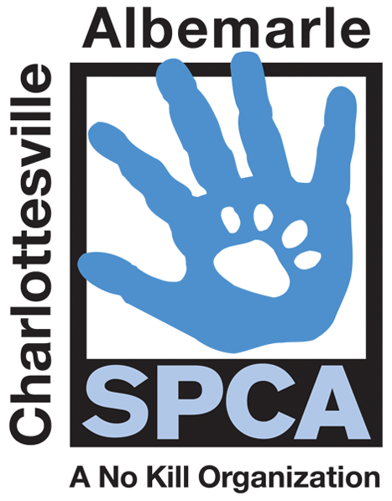

FOR IMMEDIATE RELEASE Contact: Lisa Lane
Charlottesville-Albemarle SPCA (434) 964-3305 | (805) 451-0154
04/09/2014 llane@caspca.org

This Saturday “Paws” for a Picture at BMW of Charlottesville

Charlottesville, Virginia: This Saturday, April 19th from 1:00 PM to 4:00 PM, BMW of Charlottesville is hosting an Easter-themed SPCA Adoption Eggs-travaganza! Adoptable SPCA pets, all certified pre-owned with love guaranteed, will be on hand and ready to go on test-walk. Guests are invited to “paws” for a picture in our Easter-themed photo booth, with an SPCA pet or a beloved pet of their own; themed costumes will be provided. This family-friendly event is free, and all adoptions will be discounted to an amazing $10 for cats and $25 for regularly-priced dogs!

“Just like everyone, we are so glad that Spring is here. The nice weather gives us the chance to take our adoptable pets out into the community, providing them with the best chance to find their match. We are also thankful to BMW for hosting this event and providing their ongoing support of our SPCA’s No Kill mission,” says Lisa Lane, Director of Marketing and Development at the Charlottesville-Albemarle SPCA.

BMW of Charlottesville is located at 1295 Richmond Road (250 East/Pantops).

The mission of the Charlottesville-Albemarle SPCA is to provide a safe and nurturing environment for the lost, abandoned, and homeless animals of the City of Charlottesville and the County of Albemarle and to increase the number of these animals being placed in appropriate, loving, and permanent homes through adoptions, foster care, and outreach, and to set a standard of excellence and leadership in shelter animal care, humane education, and progressive animal welfare programs.

For more information about the Charlottesville-Albemarle SPCA call 434-973-5959 or visit our website at www.caspca.org. The SPCA’s main adoption center is located at 3355 Berkmar Drive in Charlottesville and is open seven days a week from 12 PM– 6 PM.
#######################

