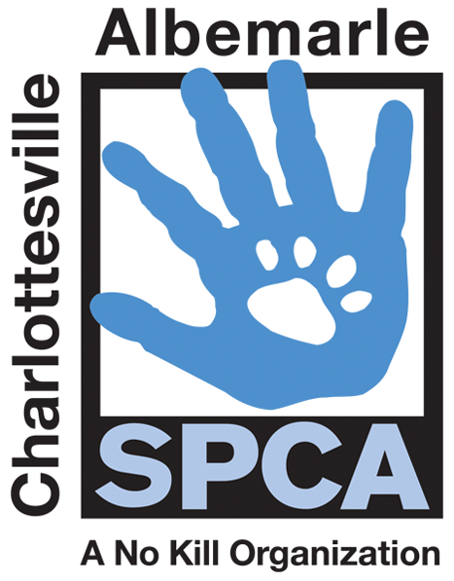

FOR IMMEDIATE RELEASE Contact: Lisa Lane
Charlottesville-Albemarle SPCA (434) 964-3305 | (805) 451-0154
07/11/2014 llane@caspca.org

Charlottesville-Albemarle SPCA Saves Dogs from Page County Puppy Mill Bust and Neighboring Animal Shelters

Charlottesville, Virginia: After adopting out more than 100 pets during its FREEdom adoption special, the Charlottesville-Albemarle SPCA has opened up space in its kennels to save the lives of more than a dozen dogs from area shelters and the Page County Puppy Mill bust. The SPCA was able to take in three dogs from Buckingham County, four dogs and a hedgehog from Shenandoah Valley Animal Services and eight dogs from the Page County Puppy Mill Bust from Animal Rescue Corps.

From the Page County Puppy Mill, the Page County Sheriff’s Office, Page County Animal Control and the Washington D.C. organization, Animal Rescue Corps, rescued 134 dogs in total. Many of these dogs were suffering from untreated infections, broken bones, hernias, respiratory conditions, and had been living in filthy conditions often seen in large scale breeding operations. Area rescues and shelters are coming together to assist with medical care and placing the dogs.

According to the SPCA Medical Director, many of the dogs at the SPCA from the Page County Puppy Mill are suffering from severe disease and will need dental surgery prior to adoption, which the SPCA will provide. All dogs will be medical and behaviorally evaluated and spayed/neutered prior to adoption.

“We are so thankful to be in the position to help Animal Rescue Corps give these dogs a chance at loving homes. We are also always happy to help our neighboring animal welfare organizations save more lives,” says Laura Jones, SPCA Director of Operations. “In the case of a large seizure like the one in Page County, it takes many organizations working together to save the lives of hundreds of pets in need.”

Many of the rescued dogs are now available for adoption at the SPCA and others are still receiving medical care. The public can meet the dogs at the SPCA daily between Noon and 6PM.

The mission of the Charlottesville-Albemarle SPCA is to provide a safe and nurturing environment for the lost, abandoned, and homeless animals of the City of Charlottesville and the County of Albemarle and to increase the number of these animals being placed in appropriate, loving, and permanent homes through adoptions, foster care, and outreach, and to set a standard of excellence and leadership in shelter animal care, humane education, and progressive animal welfare programs.

For more information about the Charlottesville-Albemarle SPCA call 434-973-5959 or visit our website at www.caspca.org. The SPCA’s main adoption center is located at 3355 Berkmar Drive in Charlottesville and is open seven days a week from 12 PM– 6 PM

#######################

