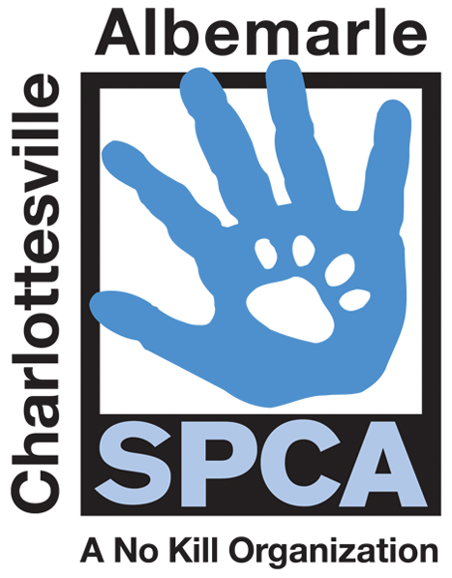

FOR IMMEDIATE RELEASE Contact: Lisa Lane
Charlottesville-Albemarle SPCA (434) 964-3305 | (805) 451-0154
10/09/2014 llane@caspca.org

Hollymead PetSmart to host Pumpkin, Pooches and Purrs
Adoption Extravaganza on Saturday, October 18th

Charlottesville, Virginia: The Charlottesville-Albemarle SPCA invites the public to fall in love with a furry friend at their Pumpkin, Pooches and Purrs Adoption Extravaganza on Saturday, October 18th from 11AM to 5PM at the PetSmart in the Hollymead Shopping Center. The SPCA is making it easier on the pocketbook to fall in love by discounting adoption fees to $5 for cats or kittens, $20 for dogs and $100 for puppies! All pets will have received services normally costing hundreds of dollars, including spay/neuter, age-appropriate vaccinations, de-worming, FIV/Felv testing (cats only), a Save-This-Life Microchip with lifetime registration, plus a free medical exam from participating vets, a free animal behavior CD and a lifetime of priceless companionship and fun.

All SPCA adopters will get a chance to draw from the Magic Pumpkin of Savings for a chance at a totally FREE adoption. There is a one in ten chance of winning. The event will also feature food trucks, a raffle and a Halloween-themed photo booth. Liz Knutsen Photography is donating their time and talents for the photo booth, inviting adopters and others to pose for a complimentary family portrait with their pet. Several local adoption groups will have pets in need of homes at the event, including Charlottesville-Albemarle SPCA, Madison Greene Humane Society and Peaceful Passings rescue group.

The mission of the Charlottesville-Albemarle SPCA is to provide a safe and nurturing environment for the lost, abandoned, and homeless animals of the City of Charlottesville and the County of Albemarle and to increase the number of these animals being placed in appropriate, loving, and permanent homes through adoptions, foster care, and outreach, and to set a standard of excellence and leadership in shelter animal care, humane education, and progressive animal welfare programs.

For more information about the Charlottesville-Albemarle SPCA call 434-973-5959 or visit our website at www.caspca.org. The SPCA’s main adoption center is located at 3355 Berkmar Drive in Charlottesville and is open seven days a week from 12 PM– 6 PM. #######################

