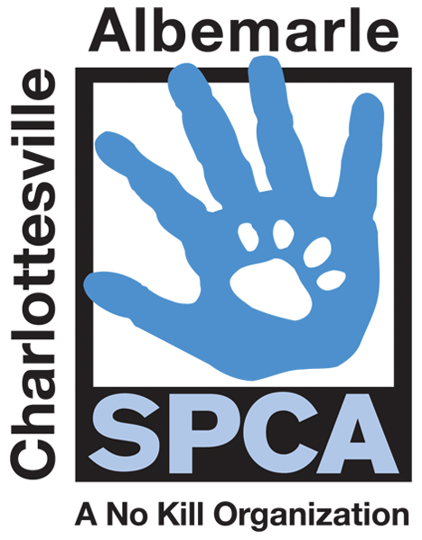

FOR IMMEDIATE RELEASE Contact: Lisa Lane
Charlottesville-Albemarle SPCA (434) 964-3305 | (805) 451-0154
10/04/2014 llane@caspca.org

Dogtoberfest Pool Pawty This Sunday at the ACAC Waterpark
to Benefit the Animals at the SPCA

Charlottesville, Virginia: ACAC Fitness and Wellness Center is hosting Dogtoberfest, a doggie pool party, this Sunday from 3 to 5PM at their Adventure Central location. This four-legged friendly festival will feature a doggie swimming pool, a splash play area for smaller dogs, a lap pool for human swimming, music, raffle prizes, a photo booth complete with doggie costumes, BBQ and beer from our friends at Three Notch’d Brewing.

Tickets are $25 and can be purchased at any ACAC location or at the door. Kids under 12 are free. All proceeds go to help the animals at the Charlottesville-Albemarle SPCA. There is a two dog limit per adult. Dogs should arrive on leash, must be altered and have an up-to-date rabies vaccine. ACAC Adventure Central is located at 200 Four Seasons Drive in Charlottesville. Please visit www.caspca.org for details.

The mission of the Charlottesville-Albemarle SPCA is to provide a safe and nurturing environment for the lost, abandoned, and homeless animals of the City of Charlottesville and the County of Albemarle and to increase the number of these animals being placed in appropriate, loving, and permanent homes through adoptions, foster care, and outreach, and to set a standard of excellence and leadership in shelter animal care, humane education, and progressive animal welfare programs.

For more information about the Charlottesville-Albemarle SPCA call 434-973-5959 or visit our website at www.caspca.org. The SPCA’s main adoption center is located at 3355 Berkmar Drive in Charlottesville and is open seven days a week from 12 PM– 6 PM.

#######################

