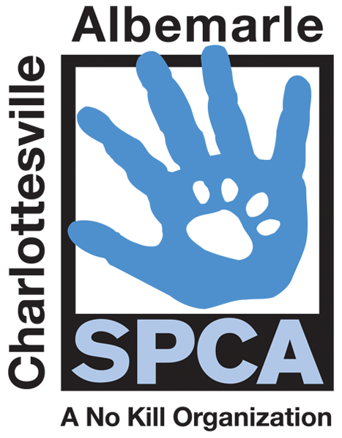

FOR IMMEDIATE RELEASE Contact: Lisa Lane
Charlottesville-Albemarle SPCA (434) 964-3305 | (805) 451-0154
10/30/2014 llane@caspca.org

Shop Locally Made Crafts While Supporting Animals in Need!

Charlottesville, Virginia: Get a head start on your holiday shopping at the annual Pre-Holiday Crafts for Critters Fair and Adoption Event! On Saturday, November 15th from 10 am to 4 pm at the Holiday Inn located at 1901 Emmet Street you can shop a wide variety of locally made arts, crafts, edibles and more, and in doing so, support the animals at the Charlottesville-Albemarle SPCA. The vendors represented at the 2014 Crafts for Critters Fair will offer everything from handcrafted soaps and candles, to pottery and handmade jewelry and more. Adoptable pets will also be on-hand. At this event, adoption fees will be waived for all adult cats and kittens will be just $25. This adoption deal even includes services normally costing hundreds of dollars: spay/neuter, age appropriate vaccinations, deworming, Felv testing, a free visit to participating vets, a microchip with lifetime registration, a bag of Science Diet kitten food, an animal behavior CD and a lifetime of priceless love and companionship. There will also be an opportunity to win raffle prizes with all proceeds going to support the SPCA.

Lisa Lane, SPCA Director of Marketing and Development noted, “This event offers the community a gift shopping opportunity that they can feel good about. You can find that special gift for just about everyone on your list while shopping locally made items and supporting animals in need.” Long-time Crafts for Critters organizer, Heather Gerry of Jade Butterfly Crafts explained, “We are so grateful for all the artists and business partners for making the Crafts for Critters show possible year after year. Many of the Crafters have been participating in this event for more than five years! We all just love the opportunity to support an organization doing so much for animals in our local community.”

The mission of the Charlottesville-Albemarle SPCA is to provide a safe and nurturing environment for the lost, abandoned, and homeless animals of the City of Charlottesville and the County of Albemarle and to increase the number of these animals being placed in appropriate, loving, and permanent homes through adoptions, foster care, and outreach, and to set a standard of excellence and leadership in shelter animal care, humane education, and progressive animal welfare programs.

For more information about the Charlottesville-Albemarle SPCA call 434-973-5959 or visit our website at www.caspca.org. The SPCA’s main adoption center is located at 3355 Berkmar Drive in Charlottesville and is open seven days a week from 12 PM– 6 PM. #######################

