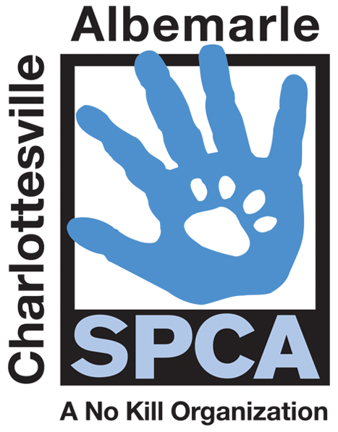

FOR IMMEDIATE RELEASE Contact: Lisa Lane
Charlottesville-Albemarle SPCA (434) 964-3305 | (805) 451-0154
07/18/2014 llane@caspca.org

Charlottesville-Albemarle SPCA to Host First Annual
Animal Art Camp For At-Risk Youth

Charlottesville, Virginia: The Charlottesville-Albemarle SPCA (“SPCA”) is bringing together children, companion animals and the arts by offering a new three-week summer program for economically disadvantaged youths. The three one-week sessions are designed to foster empathy in children who are at a pivotal point in their lives for developing compassion and fostering tolerance, which boosts their emotional intelligence, one of the greatest predictors of academic and life success.

This project has two goals. Firstly, to provide a meaningful empathy-building camp experience for at-risk youth through the promotion and understanding of the pet/person bond and secondly, to revitalize the SPCA’s retired pet cemetery into a peaceful memorial garden providing a palliative space for the community to honor and remember their pets. This garden will be enjoyed by the thousands of people who visit the SPCA each year, as well as the hundreds of SPCA volunteers walking dogs on the SPCA’s quarter-mile dog walking path, which will wind its way by the garden.

The SPCA developed this camp knowing that children have a natural affinity for animals and that many children in the target demographic often do not get the same experience with companion pets as children from middle and upper income families. Research has demonstrated that children who form a bond with a companion animal are more empathetic, more likely to choose a helping profession, score higher on measures of social competence and are more oriented toward social values. Children who are empathetic tend to have many positive psychological traits—they are more resilient, better able to handle stress and overcome difficulties, and less apt to be overly aggressive. Art programs have been particularly successful in attracting and engaging youth for a number of reasons, including the thrill of creative expression, positive community recognition, learning new job skills and the use of art in communicating difficult thoughts and emotions.

Long-time Charlottesville resident and artist Virginia Gardner, best known for her “Seat of Harmony” mosaic bench on Charlottesville’s Downtown Mall, has donated her time and talents for this camp to design and work with the students to create a permanent art piece on the SPCA grounds that celebrates the pet/person bond. This first year, the campers will work with Virginia to create a mosaic bridge that will serve as the gateway to the SPCA’s new memorial grounds. Through animal interactions, lessons and artistic expression, students will learn about companion animals and their changing role throughout history, with a purpose of ultimately guiding them towards an understanding of love and respect of animals.

This day camp will run from July 28th through August 15th and is offered at no cost to participants. School counselors, social service providers and parents have referred students for this camp. Space is limited, but there are still spots left in the second and third sessions. Transportation assistance may also be provided. If you know of a rising 6th through 8th grader that would benefit from this experience, please contact the SPCA’s Education Coordinator Kaicee Robertson at volunteer@caspca.org or (434) 964-3331 for applications and more information. This camp is partially funded by the Bama Works Fund of the Dave Matthews Band.

The mission of the Charlottesville-Albemarle SPCA is to provide a safe and nurturing environment for the lost, abandoned, and homeless animals of the City of Charlottesville and the County of Albemarle and to increase the number of these animals being placed in appropriate, loving, and permanent homes through adoptions, foster care, and outreach, and to set a standard of excellence and leadership in shelter animal care, humane education, and progressive animal welfare programs.

For more information about the Charlottesville-Albemarle SPCA call 434-973-5959 or visit our website at www.caspca.org. The SPCA’s main adoption center is located at 3355 Berkmar Drive in Charlottesville and is open seven days a week from 12 PM– 6 PM

#######################

The Empathy Connection, Doris Day Animal Foundation, pp. 2-4.
Arts Programs for At-Risk Youth, How U.S. Communities are Using the Arts to Rescue Their Youth and Deter Crime, ArtsUSA, 200, pp. 3-4, 6

