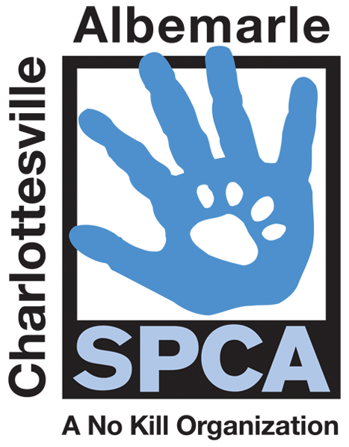

FOR IMMEDIATE RELEASE Contact: Lisa Lane
Charlottesville-Albemarle SPCA (434) 964-3305 | (805) 451-0154
08/14/2014 llane@caspca.org

CAT-egory 5 Kitten Evacuation to Take Place on Saturday, August 23rd

Charlottesville, Virginia: The Charlottesville-Albemarle SPCA invites the public to its biggest kitten adoption event of the year. With nearly 175 kittens in our care, the SPCA’s got a hurricane-size kitten situation to solve, so on Saturday, August 23rd, we will be evacuating our kittens and cats to the PetSmart in the Hollymead Center for the best feline adoption event ever recorded! To encourage people to take home a new family member at the event, adoption fees will be discounted to just $5 for all felines. Your five-dollar feline will have received services normally costing hundreds of dollars like spay/neuter, age-appropriate vaccinations, de-worming, FIV/Felv testing, a Save-This-Life Microchip with lifetime registration, plus a free medical exam from participating vets, a free animal behavior CD and a lifetime of priceless companionship and fun.

The Charlottesville-UVA-Albemarle Office or Emergency Management will also be on hand to provide pet emergency preparedness tips. Not only will there be plenty of feline fun and games, we will also have food trucks featuring human treats in the PetSmart parking lot and a chance for attendees to win raffle prizes. The Cat-egory 5 Kitten Evacuation will run from 11AM to 4PM at the PetSmart in the Hollymead Center.

The mission of the Charlottesville-Albemarle SPCA is to provide a safe and nurturing environment for the lost, abandoned, and homeless animals of the City of Charlottesville and the County of Albemarle and to increase the number of these animals being placed in appropriate, loving, and permanent homes through adoptions, foster care, and outreach, and to set a standard of excellence and leadership in shelter animal care, humane education, and progressive animal welfare programs.

For more information about the Charlottesville-Albemarle SPCA call 434-973-5959 or visit our website at www.caspca.org. The SPCA’s main adoption center is located at 3355 Berkmar Drive in Charlottesville and is open seven days a week from 12 PM– 6 PM. #######################

