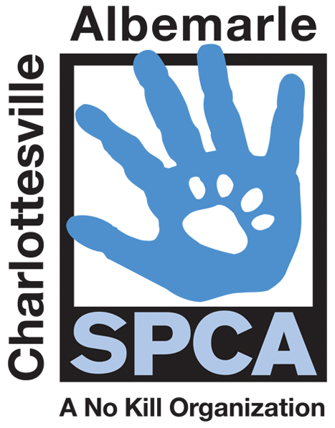

FOR IMMEDIATE RELEASE Contact: Lisa Lane
Charlottesville-Albemarle SPCA (434) 964-3305 | (805) 451-0154
05/01/2014 llane@caspca.org

SPCA Announces 1st Annual Bow-WOW-Walk

Charlottesville, Virginia: On Saturday, May 31st, the Charlottesville-Albemarle SPCA is holding the 1st annual Bow-WOW-Walk K-9 2.5K presented by Virginia National Bank to support the SPCA’s lifesaving programs. The walk will begin in Lee Park at 10AM and wind its way through Charlottesville’s historic downtown mall neighborhood before returning to Lee Park for a post walk festival that promises to WOW our doggie friends. The animal-friendly festival will run from 11AM to 2PM and will feature human and doggie entertainment, canine competition, treats for humans and pups and a pack of animal friendly vendors and sponsors.

The public is invited to register now at caspca.org. Being part of the Bow-WOW-Walk is so much more than just a single day of fun. Supporters are encouraged to form teams and fundraise amongst friends to support our local animals in need. The SPCA has a goal to raise more than $35,000 to support their programs, including subsidized spay/neuter, animal medical care and humane education.

“Participants in our inaugural walk are leading the way to help us save animal lives in our community. This event is completely underwritten by support from our generous sponsors, so every registration fee, and every dollar raised goes to support our animals in need,” says SPCA Director of Marketing and Development. “With help from our animal loving community, we hope to attract hundreds of walkers to this first-time event and have it become a recognized annual event for animal lovers in our community.”

Registration is $35 and includes a commemorative T-shirt, doggie bandana and a walker goodie bag. The public can register online at caspca.org or at the SPCA’s front desk. Registration and shirts are only guaranteed to those who pre-register. Same day registration will begin at 9AM in Lee Park.

Our generous walk sponsors include: Virginia National Bank as the Top Dog presenting sponsor; Pampered Pets and McDonalds as Struttin’ Mutt Sponsors; Doggie Do Gooders--Crutchfield, Dixon Disposal, Monticello Animal Hospital, Natural Pet Essentials, Pet Food Discounters; and the Supporting Pup Sponsors—Animal Connection, Canine Adventure, Georgetown Veterinary Hospital, Mosquito Authority, Raising Canes, Virginia Animal Law Society, RKG, Darrell & King, and Able Insurance. Special thanks to our media sponsor: NBC29.

The mission of the Charlottesville-Albemarle SPCA is to provide a safe and nurturing environment for the lost, abandoned, and homeless animals of the City of Charlottesville and the County of Albemarle and to increase the number of these animals being placed in appropriate, loving, and permanent homes through adoptions, foster care, and outreach, and to set a standard of excellence and leadership in shelter animal care, humane education, and progressive animal welfare programs.

For more information about the Charlottesville-Albemarle SPCA call 434-973-5959 or visit our website at www.caspca.org. The SPCA’s main adoption center is located at 3355 Berkmar Drive in Charlottesville and is open seven days a week from 12 PM– 6 PM.
#######################

