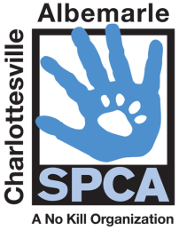
Volunteer Position Description
Laundry Volunteer

Position Title: Laundry Volunteer

Purpose: Laundry Volunteer is responsible for laundering in the three laundry rooms on the first floor of the building. Laundry Volunteers are also responsible for maintaining cleanliness and organization of all laundry areas.

Location: Laundry Volunteers assist at our main shelter:
3355 Berkmar Drive, Charlottesville, VA 22901
Key Responsibilities:

    - Sort dirty laundry and ensure all debris is clear
    - Load and unload washer and dryers
    - Fold clean laundry and return to appropriate area; maintain organization of laundered items

Responsible to: Samantha Davis, Volunteer Coordinator; Ryan Willis, Animal Care Manager

Time Commitment: 9-12:00 a.m. and 2-5:00 p.m. Saturday and Sundays. Minimum one shift per month.

Qualifications: Ability to bend, squat, lift up to 40 pounds. Able to safely work with cleaning agents (bleach, laundry detergent, etc.) and follow sanitization protocols and OSHA guidelines. Accepts the guidance of staff when provided. Professional attitude and ability to work with others is a must.

Support: Training for this position will be provided. In addition, the Animal Care Manager and Assistant Manager, and the Volunteer Coordinator will be available for questions and assistance.

Dress Code: CASPCA volunteer shirt, non-slip closed toe shoes

Volunteer Name (print) Volunteer Signature Date

Volunteer Coordinator Signature Rummage Store Manager Signature Date
REVISED: 5/11/16

